Microsoft Azure - Starter Kits for Partners

Statement of Work (Sample)

Development & Test Scenario

Last Update: September 2015





**MICROSOFT MAKES NO WARRANTIES, EXPRESS, IMPLIED OR STATUTORY, AS TO THE INFORMATION IN THIS DOCUMENT.**

The information contained in this document represents the current view of Microsoft Corporation on the issues discussed as of the date of publication. Because Microsoft must respond to changing market conditions, it should not be interpreted to be a commitment on the part of Microsoft, and Microsoft cannot guarantee the accuracy of any information presented after the date of publication.

Complying with all applicable copyright laws is the responsibility of the user. Without limiting the rights under copyright, no part of this document may be reproduced, stored in or introduced into a retrieval system, or transmitted in any form or by any means (electronic, mechanical, photocopying, recording, or otherwise), or for any purpose, without the express written permission of Microsoft Corporation.

Microsoft may have patents, patent applications, trademarks, copyrights, or other intellectual property rights covering subject matter in this document. Except as expressly provided in any written license agreement from Microsoft, the furnishing of this document does not give you any license to these patents, trademarks, copyrights, or other intellectual property.

The descriptions of other companies’ products in this document, if any, are provided only as a convenience to you. Any such references should not be considered an endorsement or support by Microsoft. Microsoft cannot guarantee their accuracy, and the products may change over time. Also, the descriptions are intended as brief highlights to aid understanding, rather than as thorough coverage. For authoritative descriptions of these products, please consult their respective manufacturers.

© 2014 Microsoft Corporation. All rights reserved. Any use or distribution of these materials without express authorization of Microsoft Corp. is strictly prohibited.

Microsoft and Windows are either registered trademarks of Microsoft Corporation in the United States and/or other countries.

The names of actual companies and products mentioned herein may be the trademarks of their respective owners.

Contents

Overview 4

Scenario Overview 6

Why Dev and Test on Microsoft Azure? 6

Develop and test applications faster 6

Access the latest development tools in minutes 6

Deploy on-premises or in the cloud 6

The Proposed Solution 7

Azure Infrastructure Estimated Price 8

Fee Schedule 8

Scope of Work 8

Areas Out of Scope 9

Period of Performance 10

Engagement Resources 10

[Company Name] Project Roles and Responsibilities 10

Customer Project Roles and Responsibilities 10

Delivery Methodology 11

Deliverable Materials 11

General Customer Responsibilities and Project Assumptions 12

General Customer Responsibilities 12

Project Assumptions 12

Conditions of Satisfaction 13

Suggested Sections/Topics to be added by the Partner 13

# Overview

The purpose of this document is to provide Microsoft Partners with a **sample** Statement of Work (SOW) that they can use as a reference to propose to their customers an engagement for deploying an Azure Dev and Test scenario.

Although this sample aims at facilitating and accelerating your engagements, Microsoft makes no warranty that using this template will result in a successful project, you are responsible for defining the conditions of satisfaction with your customer and delivering the proposed scenario.

In this document, we cover the following topics:

* SOW CONTRACT TEMPLATE
* THE PROPOSED SOLUTION
* FEE SCHEDULE
* SCOPE OF WORK
* AREAS OUT OF SCOPE
* PERIOD OF PERFORMANCE
* ENGAGEMENT RESOURCES
* DELIVERY METHODOLOGY
* DELIVERABLE MATERIALS
* GENERAL CUSTOMER RESPONSIBILITIES AND PROJECT ASSUMPTIONS
* CONDITIONS OF SATISFACTIOM

|  |  |
| --- | --- |
| [Company Name]  [Company Address] [City, ST ZIP Code] | Logo |

SOW [000] for Agreement to Perform Consulting Services to [Client Name]

Statement of Work

|  |  |  |
| --- | --- | --- |
| Date | Services Performed By: | Services Performed For: |
| [Date] | [Company Name]  [Company Address] [City, ST ZIP Code] | [Client Name]  [Client Address] [City, ST ZIP Code] |

|  |  |
| --- | --- |
|  | Placeholders for your content that appear in the paragraph text are shown in red and will change to the default text color when you add your content. Information that repeats in the document (such as client name) will be updated in all locations when you add or edit it once.  The text provided is sample SOW text that you can edit as applicable for your business.  Note: to delete any tip, such as this one, just click the tip text and then press the spacebar. |

This Statement of Work (SOW) is issued pursuant to the Consultant Services Master Agreement between [Client Name] (“Client”) and [Company Name] (“Contractor”), effective [Click to select date] (the “Agreement”). This SOW is subject to the terms and conditions contained in the Agreement between the parties and is made a part thereof. Any term not otherwise defined herein shall have the meaning specified in the Agreement. In the event of any conflict or inconsistency between the terms of this SOW and the terms of this Agreement, the terms of this SOW shall govern and prevail.

This SOW # [000] (hereinafter called the “SOW”), effective as of [Click to select date], is entered into by and between Contractor and Client, and is subject to the terms and conditions specified below. The Exhibit(s) to this SOW, if any, shall be deemed to be a part hereof. In the event of any inconsistencies between the terms of the body of this SOW and the terms of the Exhibit(s) hereto, the terms of the body of this SOW shall prevail.

In this project, [Company Name] (“Contractor”) will assist you with building a lab solution in Microsoft Azure.

This solution delivers a development and test lab running in Microsoft Azure and automated using PowerShell and the Microsoft Azure SDK (Software Development Kit). [Company Name] Will assist in the design, deployment, and integration of the solution and leads solution walk through with customer staff.

# Scenario Overview

## Why Dev and Test on Microsoft Azure?

Microsoft Azure enables you to develop and test applications faster, at reduced cost, and with the flexibility to deploy in the cloud or on-premises.

### Develop and test applications faster

Rapidly self-provision as many virtual machines as you need for your application development and testing in the cloud without waiting for hardware, procurement or internal processes. Connect globally to your on-premises network with Azure Virtual Network and confidently scale up, scale out, and generate load to deliver applications faster.

### Access the latest development tools in minutes

Visual Studio 2013 is the best IDE for cloud development and test – and enables powerful scenarios including running Visual Studio in the cloud, plus the ability to manage cloud resources from Visual Studio. MSDN subscribers can use pre-configured Visual Studio 2013 Azure virtual machine images to get up and running in a flash.

### Deploy on-premises or in the cloud

Use Azure to develop and test your application faster, at a reduced cost, and then choose where to deploy them. You can go into production on Azure, or export your virtual machine and go live on-premises or with a hosting provider. The choice is yours.

Developers building on-premises applications or migrating on-premises applications to the cloud will immediately see the above benefits by using Azure Virtual Machines. In addition, Azure also provides several services that can be used to develop and test a variety of applications. Some of these services include Azure Websites, Mobile Services, Cloud Services, SQL Databases, and Azure Storage.

**Summary**:

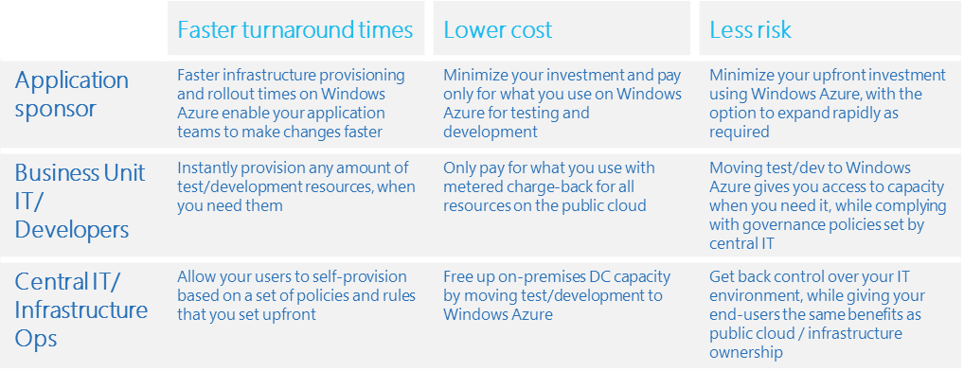

# The Proposed Solution

You can leverage Azure as the infrastructure of your Dev and Test Environment for several applications, such as **SAP NetWeaver Application, SharePoint, BizTalk**, and many other.

For this engagement, we are covering a Dev and Test Lab infrastructure for a Custom Web Application deployed in IIS – Internet Information Services Farm using SQL Server 2012 as Database application.

EXTRACTED FROM ARCHITECTURE VISIO DOCUMENT– UPDATE IF ARCHITECTURE CHANGES



## Azure Infrastructure Estimated Price

If your company owns a MSDN subscription, you can enjoy up to $150 in credits on Azure with reduced Windows Server rates and use your MSDN software such as SQL Server for no **additional licensing fee**.

EXTRACTED FROM COST ESTIMATOR DOCUMENT– UPDATE IF ARCHITECTURE CHANGES

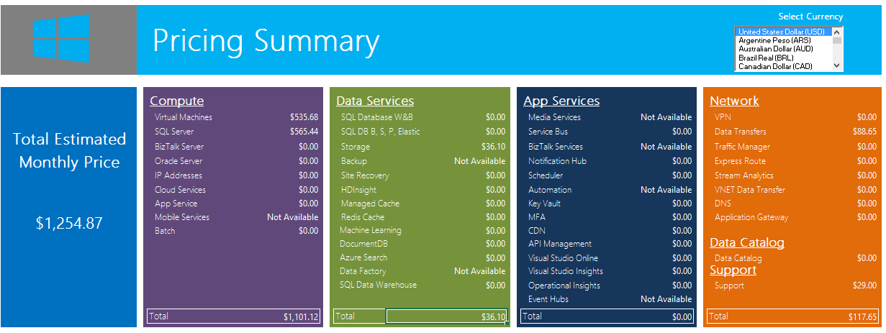

# Fee Schedule

This engagement will be conducted on a Time & Materials basis. The total value for the Services pursuant to this SOW shall not exceed [$000] unless otherwise agreed to by both parties via the project change control procedure, as outlined within. A PCR will be issued specifying the amended value.

# Scope of Work

In this project, [Company Name] (“Contractor”) will assist you with building a lab solution in Microsoft Azure. This solution delivers a development and test lab running in Microsoft Azure and automated using PowerShell and the Microsoft Azure SDK (Software Development Kit). [Company Name] Will assist in the design, deployment, and integration of the solution and leads solution walk through with customer staff.

**Note:** You can leverage Azure as the infrastructure of your Dev and Test Environment for several applications, such as **SAP NetWeaver Application, SharePoint, BizTalk**, and many other. For this engagement, we are covering a Dev and Test infrastructure for a Custom Web Application deployed in IIS – Internet Information Services Farm using SQL Server 2012 as Database application.

|  |  |
| --- | --- |
| Work Item | Scope |
| General technical deployment guidance provided by [Company Name] | |
| Activities/Tasks | 1. Assessment Phase    * Review technical requirements for the project and perform assessment and remediation tasks accordingly 2. Configure Microsoft Azure    * Create Microsoft Azure Tenant (if needed)    * Create admin and co-admins    * Create Virtual Network    * Create Azure Storage Account    * Create VM from Gallery    * Create Cloud Services    * Configure Load balancing - Endpoints    * Create Data Disks    * Create Availability Sets 3. Configure Domain Controller (If needed)    * Install Domain Controller and Active Directory (If Needed) 4. Configure Web Server - Internet Information Services (IIS)    * Create Virtual Application    * Configure Protocols (HTTP/HTTPS)    * Configure Authentication Mechanism    * Configure Load Balancing 5. Configure SQL Server Infrastructure    * Configure VM with SQL Server      + Attach Disk      + Configure Data and Logs Disk source      + Configure Firewall      + Join Domain (If needed) 6. Configure Deployment Strategy    * Configure Web Deploy    * Configure PowerShell 7. Test Application    * Test access to application through Browser    * Test Load balancing requirement    * Test Deployment process through PowerShell/TFS |
|  |  |

# Areas Out of Scope

Any area that is not explicitly listed in section “Scope of Work” is out of scope for this engagement. The areas that are out of scope for this engagement include, but are not limited to, the following:

* Migration of any source system or data not explicitly declared as part of the scope.
* Overall program and project management.
* Management of customer resources.
* Creation of end-user communications, documentation, training, or change management.
* Application co-existence configuration necessary on the application side.
* Support or assistance for implementing changes to customer identity provisioning processes.
* Technical change management approval process and supporting documentation.
* Microsoft Official Curriculum delivery.
* Configuration and deployment of the Site to Site VPN in the on premises datacenter.

INCLUDE MORE

# Period of Performance

The Services shall commence on [Click to select date], and shall continue through [Click to select date].

The total work, including, hands-on activities, technical meetings and answer to e-mails, is limited to a maximum of XXXX hours delivered remotely or on site during the course of the project

# Engagement Resources

### [Company Name] Project Roles and Responsibilities

|  |  |  |
| --- | --- | --- |
| Role | Responsibilities | Project Commitment |
| Engagement Manager | * Responsible for deliverable quality and Customer’s overall satisfaction * Single point of contact for billing issues, personnel matters, contract extensions, and project status * Stakeholder communication issue resolution and escalation | 2 hours / week |
| IT Consultant | * Responsible for planning and execution of solution | 40 hours / week |
| Developer Consultant | * Responsible for planning and execution of solution | 10 hours / week |

### Customer Project Roles and Responsibilities

|  |  |  |
| --- | --- | --- |
| Role | Responsibilities | Typical Time Commitment |
| Customer Project Sponsor | * Makes key project decisions, assists in escalating unresolved issues, and clears project roadblocks | 2 hours / week throughout |
| Customer Project Manager | * Primary point of contact for * Responsible for managing and coordinating the overall project * Responsible for resource allocation, risk management, project priorities, and communication to executive management * Manages day-to-day activities of the project * Coordinates the activities of the team to deliver deliverables according to the project schedule | Full time during planning; avg. 10 hours |
| Infrastructure Lead | * Primary technical point of contact for the team that is responsible for technical architecture and code deliverables | Full time during planning; avg. 10 hours |
| Lab Ops Lead | * Primary functional point of contact for the team that is responsible for functional use cases and operation of the solution | Full time during planning; 10 hours |

|  |  |
| --- | --- |
|  | List names of resources and any key information about each. |

# Delivery Methodology

Add here your delivery and project management methodology. Examples of engagement methodologies.

* Scrum
* Microsoft Solution Framework

Explain how you will divide the activities based on your methodology.

# Deliverable Materials

Include any deliverable you may leave behind after the deployment is completed. E.g.

* Documentation for Environment Configuration
* Architecture and Topology Documents
* PowerShell Scripts

|  |  |
| --- | --- |
|  | If this is an SOW for deliverable work product, describe deliverables here. If this is an SOW for services that do not include specific deliverables, you might want to include a statement such as “There are no formal deliverables or work products defined in association with these services.” |

# General Customer Responsibilities and Project Assumptions

## 

## General Customer Responsibilities

Delivery of scoped items depends upon, among other things, the following:

* Customer’s involvement in all aspects of the services
* Customer’s ability to provide accurate and complete information, as needed
* Customer’s timely and effective completion of the responsibilities, as identified herein
* The accuracy and completeness of the Assumptions, identified below
* Timely decisions and approvals by Customer’s management
* Customer’s completion of site readiness activities (if applicable)

In addition to any Customer activities identified elsewhere in this SOW, Customer will perform or provide the following:

* Procure and provide access to required Azure subscriptions and capacity
* Provide written descriptions of lab use cases and scenarios
* Provide written diagrams and descriptions of the network topology connecting your datacenter to Azure
* Provide VMs and images for upload into the solution, including any necessary licensing; upload all images prior to the beginning of the planning phase
* Provide adequate bandwidth to Microsoft Azure and a Microsoft Azure supported VPN device if VPN connectivity is to be used; you are responsible for configuration of any on-premises VPN device used to connect to Microsoft Azure
* Make any and all necessary network configuration changes required to facilitate connectivity to Microsoft Azure from your datacenter and the locations from which the lab users will be accessing it
* In performing services under this SOW and the applicable Work Order, Contractor will rely upon any instructions, authorizations, approvals, or other information provided by Customer’s Project Manager or personnel duly designated by Customer’s Project Manager.

## Project Assumptions

The Services, fees, and delivery schedule for this project are based on the following assumptions:

* Any and all hardware and software components utilized on-premises are Certified for Windows Server
* All software used in the lab solution is supported for usage in Microsoft Azure by Microsoft and the respective vendor (if produced by a 3rd party)
* Your lab workload performance, capacity, and density patterns follow commonly encountered industry trends or capacity estimates and designs are adjusted to accommodate them
* You own or procure all required software licenses and Azure subscriptions
* Throughout the project, Contractor will submit requests for decisions or feedback for Customer to complete. Decisions are assigned due dates, and it is assumed that Customer will provide the required feedback or make decisions on either the due date agreed upon or (3) business days from the date of submittal. If a decision or feedback is not provided within the due date or (3) business days, it will be addressed as a potential change of scope pursuant to the Change Management process outlined in this SOW.

|  |  |
| --- | --- |
|  | Define client responsibilities. |

Completion Criteria

The project will be considered complete when any of the following conditions are met:

1. All In Scope tasks are completed; or
2. All funding has been utilized for hours of services delivered and expenses incurred; or
3. The period of performance has expired; or
4. The Work Order is terminated pursuant to the provisions of the agreement.

# Conditions of Satisfaction

Add here the criteria that define the success of this engagement. E.g.

* Internal team is able to continue development activities without changing their current process
* Infrastructure Provisioning time for testing new application features is decreased **by 50%**

# Suggested Sections/Topics to be added by the Partner

* Change Management Criteria